Meritas Fall 2015
Southeast Regional Meeting
Chamberlain Hrdlicka – Co-Sponsor
Meritas – Co-Sponsor
November 13-14
Houston, Texas

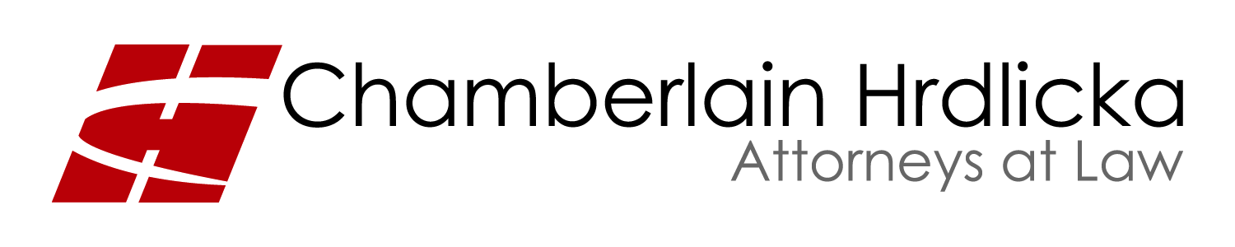

Registration Form

Firm:
Registration Contact Name: (First name for badge)
Preferred Mailing Address:
City: State: Zip/Postal Code:
Country: Telephone: ( ) Fax: ( )
Email:
Spouse/Guest Name if attending: (First name for badge)

Registration Fees (per person: attendee, spouse or guest $135.00). Includes reception, lunch, continental breakfast, dinner and transportation to dinner. The deadline for registration is October 23.

$135.00 x number of attendees _____________ $ ____________ total

Indicate interest:
___ Welcome Reception: Chamberlain Hrdlicka’s 14th Floor Lobby, November 13
___ Dinner at Brennan’s, November 13
___ Continental Breakfast, November 14
___ Lunch on Saturday, November 14
___ Menil Art Tour (spouse or guest), November 14 (AM)

Post-Meeting Optional Activities:
___ NASA
___ Golf
___ Houston Rockets

Please list any ADA Special Needs:
Please list any food allergies:

Cancellations/Changes and Refunds: Fees for missed meals, late arrivals, and early departures will not be refunded.

PAYMENT METHOD: For online registration and secure credit card transactions please go to www.chamberlainlaw.com. Registration confirmation/receipt and further information will be e-mailed to the person listed as the registration contact.

Please contact Jim Berry or Tiffiny Fayle with any questions regarding this upcoming event.
Phone: 713.658.1818
Fax: 713.658.2553
Email: rsvp@chamberlainlaw.com

Please list other firm attendees, including spouses:
Hotel: We have a limited block of rooms available at the DoubleTree Hotel Houston Downtown at the rate of $99/night. You may reserve a room by booking online at www.Doubletree.com
___________________________________________
___________________________________________
___________________________________________
1977413.1
000001..240004

